Task 3 – New Lead Notification to Marketing Team
Google Forms → Gmail Notification Automation

1. Objective
Automatically notify the marketing team whenever a new lead submits the Digital Marketing Consultation Form.

2. Trigger – New Form Response
App: Google Forms
Event: New Form Response
When a new lead submits the form, Zapier captures the submitted lead information and sends it to the Gmail action.

3. Action – Send Email Notification
App: Gmail
Event: Send Email
The notification is sent to the marketing team's email address. The email contains important lead details such as the lead's name, email, phone number, service interest, marketing challenge, budget, start timeline, and requirements.

4. Test Result
The automation was tested successfully. After a new form response was received, Zapier sent an email notification to the marketing team with the lead information.

5. Business Usefulness
This automation gives the marketing or sales team an immediate notification whenever a new lead is generated. It reduces the need to manually check form responses and helps the team respond to enquiries faster.

6. Screenshots / Evidence
1. Zapier Workflow – Google Forms to Gmail
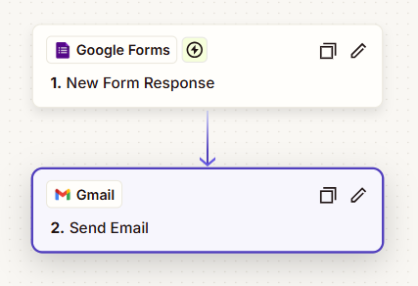
2. Gmail Action – Send Email Configuration
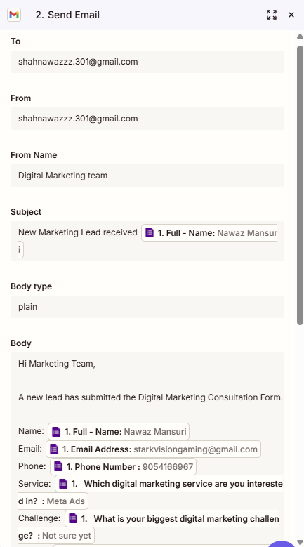
3. Successful Notification Email Received
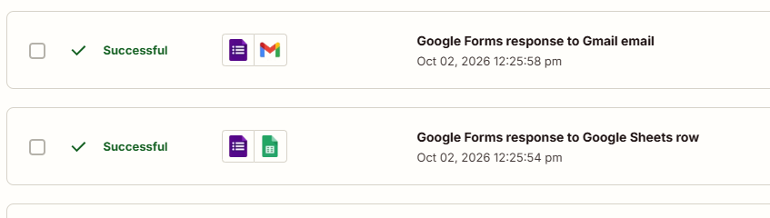
4. Zapier Task History – Successful Run
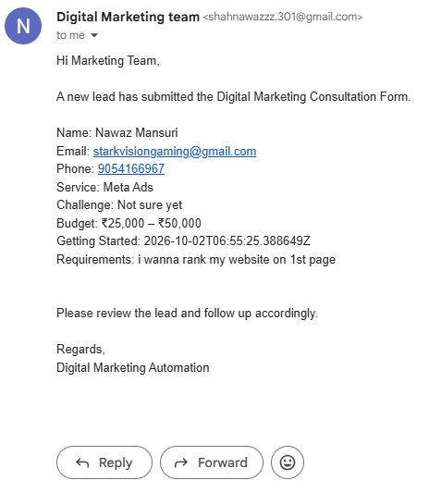

7. Submission Checklist
- Zapier workflow screenshot
- Trigger screenshot
- Gmail action screenshot
- Successful notification email screenshot
- Successful Zapier run screenshot
- 2–3 line business usefulness explanation

